Kettle Moraine
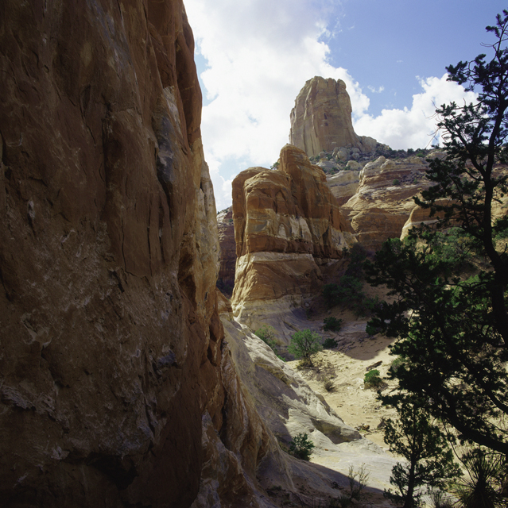

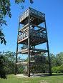
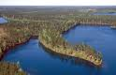

By: Braedon Knudson

On a warm day in October, Woodland went on a field trip to Kettle Moraine. We left at 8: 55 am. The first thing we did when we got there was going to the Ice Age Center to watch a presentation about glaciers. Then we left to go to Dundee Mt. It was a big hike. We stopped about four times to rest. We went back to the bus.

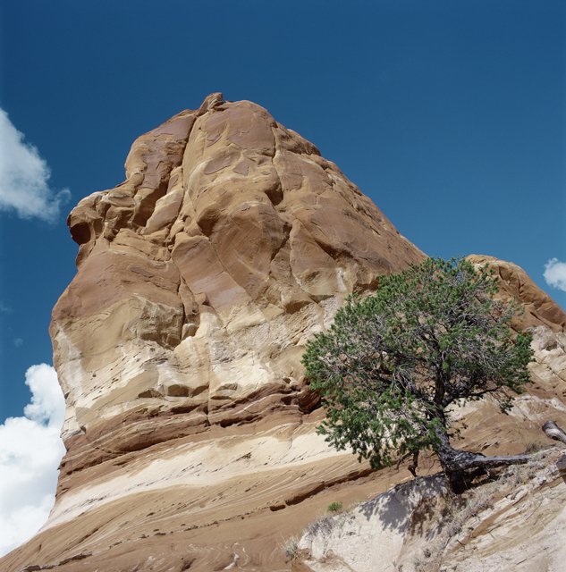

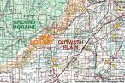

People played D.S. till we got to the place we ate lunch at. There was a humongous lake with foam in it and a gigantic hill with bathrooms. Also a water fountain, the water shot out three feet. Then we went to see an Esker. Someone sprained their ankle on it. When I was going back to the bus I saw an old fashioned water pump.

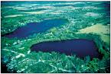

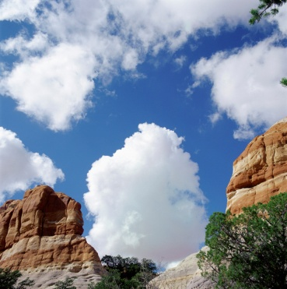
After that all of the 4th graders went to see a tower it was tall you have to walk up a lot of stairs to get to the top. We left. It felt longer the way back than the way there. I played Pokémon soul silver and beat the game it was a fun field trip. When I got back I went to y-care with my friend Josh and we played our D.S.

